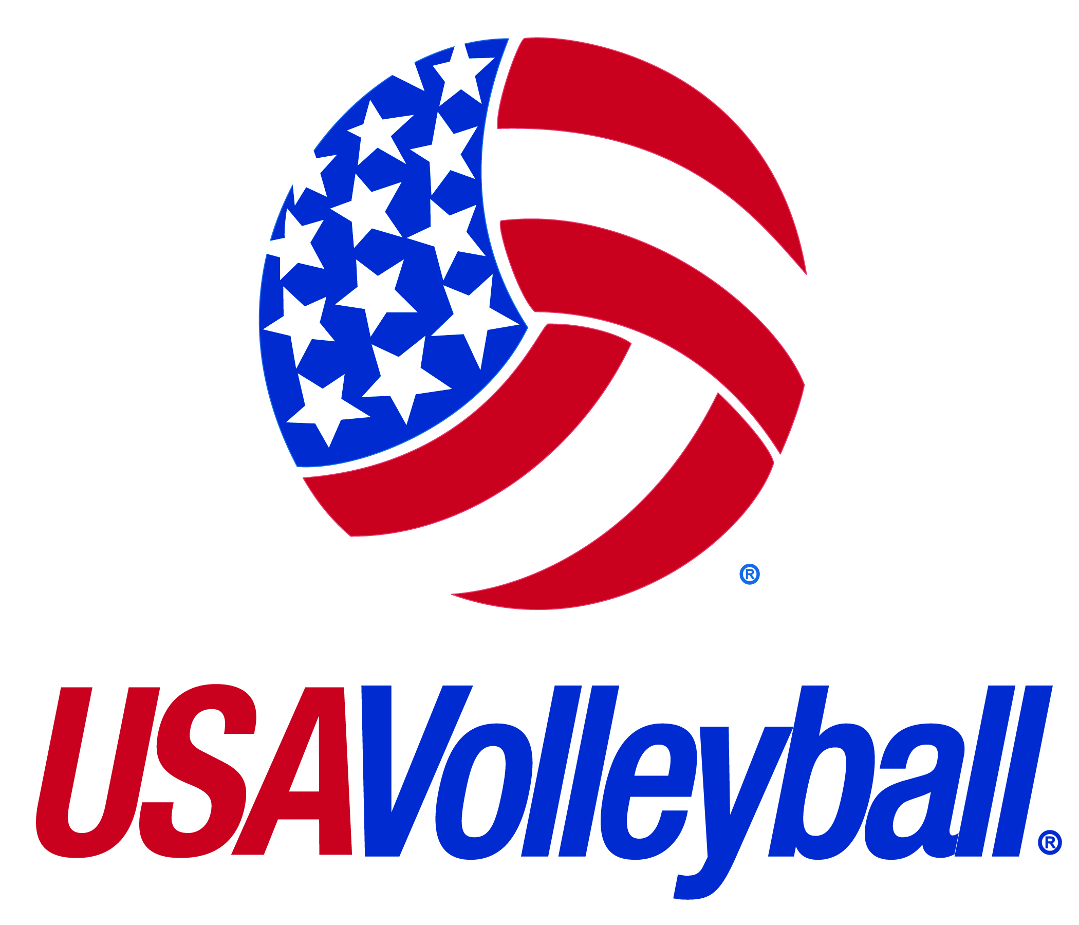

Secondary Sport Accident – Summary of Coverage for 2014-2015 Season
Foreign Participants (non-USA residents) Competing in Sanctioned USA Volleyball Events

Insurer: National Union Fire Insurance Company of PA
Claims Administrator: AIG

What is covered?
Accidental injury that occurs while participating in USA Volleyball sanctioned events.

Who is covered?
All foreign participants (non-USA residents) who complete and sign the registration form and pay the foreign participant insurance fee. This is a requirement for participation in a sanctioned event.

What are the benefits?
Excess Accident Medical – $25,000 maximum per injury
Coverage will consider the usual and customary expense for medically necessary care received at a hospital or provided by a licensed practitioner.

Accidental Death & Dismemberment - $10,000 principal sum
Coverage will consider $10,000 for the accidental loss of life and $2,500, $5,000 or $10,000 (depending on loss type) for covered incidents resulting in accidental dismemberment. Loss must occur within 365 days after the date of accident.

Is there a deductible?
Yes. The deductible for USA Volleyball’s accident medical coverage is $250. This means that the injured person must pay the first $250 of the medical bill.

Does the policy have any restrictions?
- For coverage to apply, the injury must be reported immediately to an official.
- The policy provides coverage against loss in excess of coverage provided under other valid and collectible medical insurance.
- See policy for specific exclusions.
- Claims must be filed within 90 days of treatment.

What is not covered?
- Illness or Sickness
- Re-injury and/or Pre-Existing Conditions
- Injuries caused by wear and tear of overuse, such as tendonitis, bursitis or stress fractures
- Injuries occurring elsewhere than the premises designated for competition
- Suicide or Attempted Suicide
- Fighting, unless as an innocent victim
- Hernias, in any form
- Non-prescription drugs
- Expenses incurred outside the United States

This is only a general summary of coverage and is not intended to attempt to describe all of the plan provisions. Actual coverages are detailed in the policy and are subject to the conditions contained therein.

